ITUE203: WEB DEVELOPMENT FRAMEWORKS 25CS083– YASH

Faculty of Technology and Engineering
Chandubhai S. Patel Institute of Technology (CSPIT)
Department of Computer Science & Engineering
Date: 24 / 7 / 26
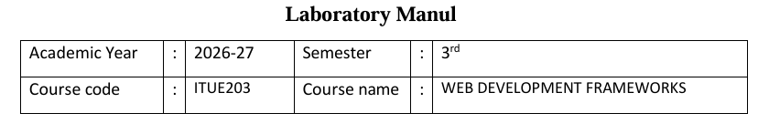
Practical – 1
PROBLEM STATEMENT : Initiate the semester-long StudentHub portal by identifying the problem
scope, user roles, key modules, navigation flow, and minimum 10 pages.
Create a sitemap, low-fidelity wireframe, project folder structure,
README file, and GitHub repository.

Objective:-
To initiate the development of a semester-long StudentHub Portal by analyzing the problem requirements, identifying the target users and their roles, designing the key functional modules, creating a clear navigation flow, and planning a minimum 10-page website. The project also aims to establish a structured development workflow by preparing a sitemap, low-fidelity wireframes, project folder structure, README documentation, and a GitHub repository for version control and collaborative development.
Screenshot :
StudentHub project folder created in VS Code.
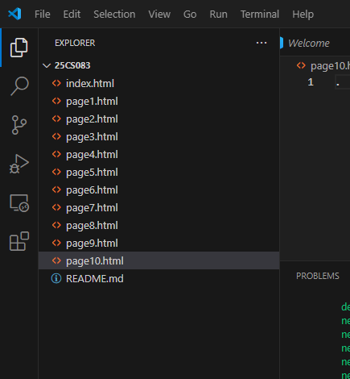
Commands:
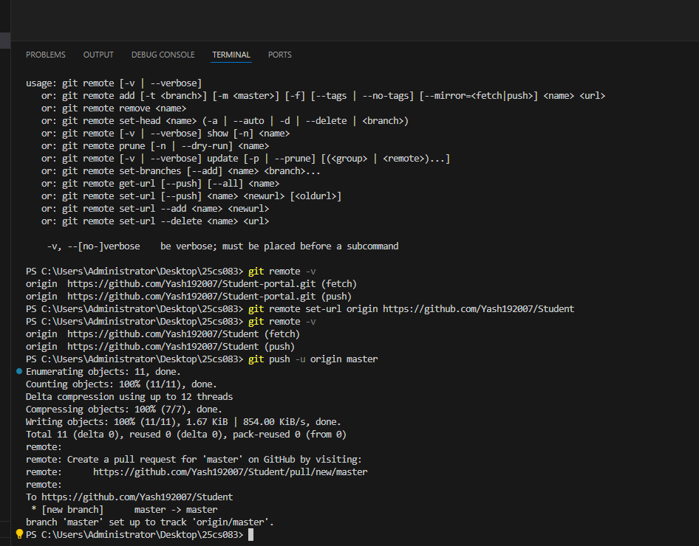
Screenshot showing the created GitHub repository and uploaded project.

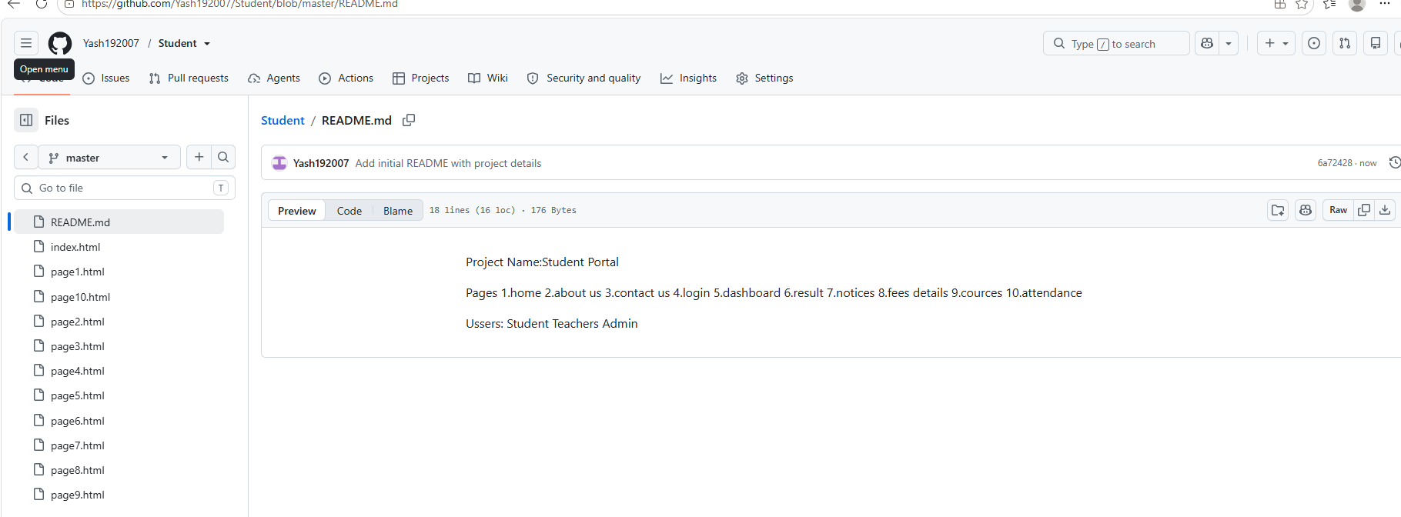
the link to GitHub repository.
Yash192007/Student at master
the sitemap created in Figma
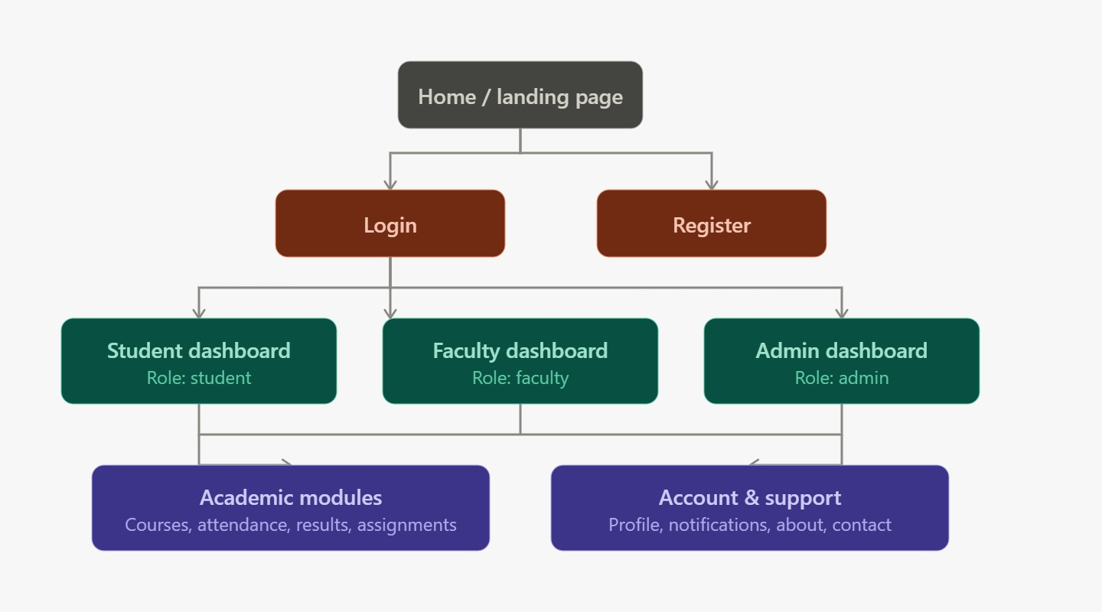

Low-Fidelity Wireframe PDF
Page-1:
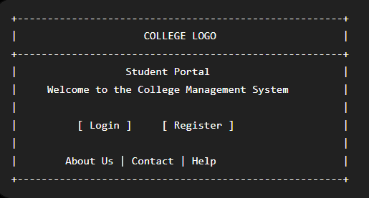

Page-2:
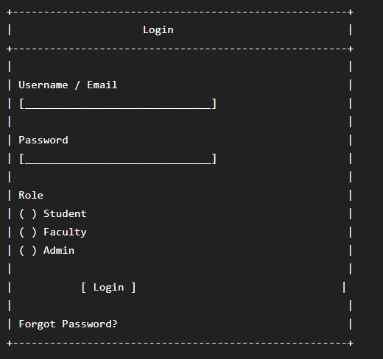
Page-3:
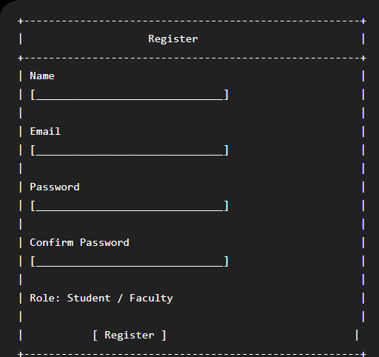
Page-4:
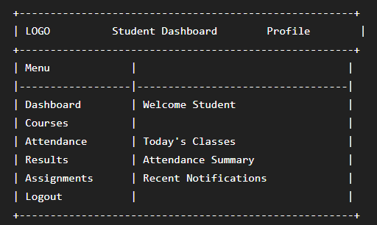
Page-5:
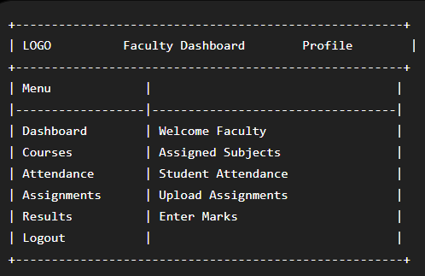
Page-6:
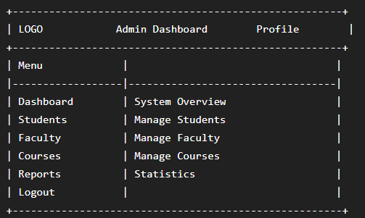
Page-7:
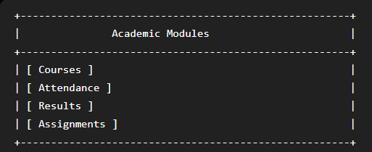
Page-8:
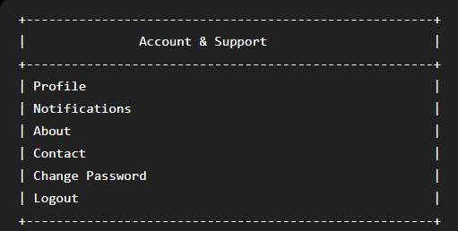
Page-9:
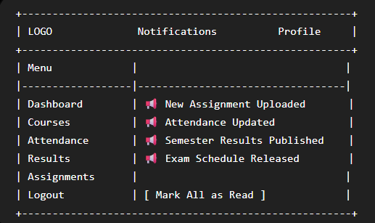
Page-10:
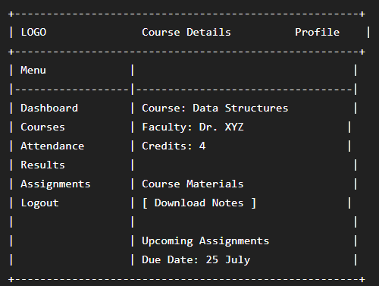
Learning outcome : Students will be able to analyze requirements and prepare a structured project foundation before implementation.

